"Methods of empirical and theoretical research"
Introduction
As Hegel emphasized: not only the result of research, but also the path leading to it, must be true. The method is a set of rules of behavior and requirements for activity formulated on the basis of knowledge about the properties of objective reality. The method is, figuratively speaking, a lantern that illuminates the way for a traveler in the dark.
Content
1. The concept of the method of scientific cognition
1. Method
2. Classification of research methods
2. Methods of empirical research
1. Observation
2. Experiment
3. Analysis and synthesis
4. Modeling method
5. Induction and deduction
Integrating scientific method
1. Methods of theoretical research
1. Formalization
2. The axiomatic method
3. Idealization
4. Modeling
5. A systematic approach
6. Structural and functional
2. The problem of interaction of theory with experience
3. List of sources

The concept of the method of scientific cognition
Methods of scientific cognition include:
• universal methods of thinking (analysis, synthesis, comparison, generalization, induction, deduction ...)
• methods of empirical and theoretical research
• for the processes of constructing theoretical knowledge systems, the method of ascent from the abstract to the concrete is of particular importance
Method (Greek methodos) — in the broadest sense of the word — "the way to something", the way of activity of the subject in any form.
The concept of "methodology" has two main meanings
• * a system of certain methods and techniques used in a particular field of activity (in science, politics, art, etc.);
• the doctrine of this system, the general theory of method, theory in action.
The main function of the method is the internal organization and regulation of the process of cognition or practical transformation of an object. Therefore, the method is a set of certain rules, techniques, methods, norms of cognition and action.
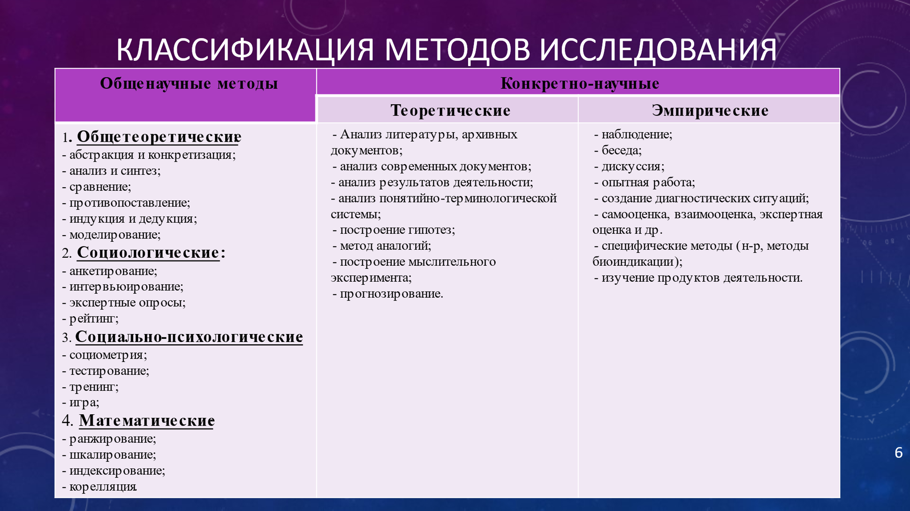
Методы эмпирического исследования


Observation
Observation is a method of directional reflection of the characteristics of an object, which allows you to form a certain idea of the observed phenomenon. The block of observation procedures includes description, measurement, comparison.
Experiment
Experiment is a more effective method, which differs from observation in that the researcher uses the experiment to actively influence the object by creating artificial conditions necessary to identify previously unknown properties of the object.
Analysis and synthesis
Empirical analysis is simply the decomposition of the whole into its component, simpler elementary parts. Synthesis is, on the contrary, a combination of components of a complex phenomenon. Theoretical analysis provides for the identification of the main and essential in the object, invisible to empirical vision. The analytical method at the same time includes the results of abstraction, simplification, formalization.

Modeling method
The modeling method is based on creating a model that is a substitute for a real object due to a certain similarity with it. The construction and study of the model is equivalent to the study and construction of the simulated object, with the only difference that the second is accomplished materially, and the first is ideal, without affecting the simulated object itself. The second important function of the model in scientific cognition is that the model acts as a program of action for the upcoming construction, construction of the simulated object
Induction and deduction.
Induction can be defined as a method of transition from knowledge of individual facts to knowledge of the general. Deduction is a method of transition from the knowledge of general laws to their particular manifestation. Theoretical induction and deduction based on it differ from empirical induction and deduction in that they are based not on the search for the abstract general, the same in different subjects and facts ("All swans are white"), but on the search for the concrete universal, on the search for the law of existence and development of the system under study
Historical and logical methods are based on dialectics, i.e. the mutual transformation of historical and logical: studying history, we learn its objective logic, studying the subject logically, we reconstruct its history.
Historicism can be abstract and concrete. Abstract historicism is an empirical method of chronological description of events without a deep understanding of their essence.
Integrating scientific method
The integrating scientific method, which includes all the previous methods as moments, is the method of ascent from the abstract to the concrete. This is a theoretical systematic method consisting in such a movement of thought that leads the researcher to an increasingly complete, comprehensive reproduction of the subject. In the process of such a movement of theoretical thought, three stages can be distinguished
• * empirical research of a given subject directly, sensually-specifically,
* the stage of ascent from the sensually concrete to the initial abstraction, to the cognition of the essence of the object,
* the stage of returning to the subject "abandoned" in the process of abstraction on the basis of knowledge of its own essence, i.e. the stage of ascent from the initial abstraction to the integral theoretically concrete concept of the subject; this is the path to concrete, essential scientific thinking that can be defined in practice.
In theoretical knowledge there are no means of material, practical interaction with the studied object. The language of theoretical research differs from the language of empirical descriptions. It is based on theoretical terms, the meaning of which is theoretical ideal objects. These are special abstractions that are logical reconstructions of reality. No theory is built without the use of such objects. Empirical knowledge can be represented by hypotheses, generalizations, empirical laws, descriptive theories, but they are directed at an object that is given to the observer directly.
Methods of theoretical research
1. axiomatic - a scientific theory is constructed in the form of axioms and rules of inference. An axiom is a statement accepted without logical proof and cannot be refuted on the basis of empirical facts. Widely used in logic and mathematics (1 straight line can be drawn through 2 points). Absolutely rejects any contradictions.
2. hypothetical-deductive method. Hypotheses are put in place of axioms. Hypothesis is knowledge that can be refuted by comparison with experimental facts. Widely used in physics, electrical engineering, economic sciences. Requires good mathematical training.
3. descriptive methods - verbal, graphic, schematic. The researcher's thought turns to the experimental data much more often, it is less likely to detect regular connections. In biology, medicine, psychology, sociology.
Theoretical methods (basic)
* idealization
* formalization
* mathematical modeling
* reflection - as the main method of metatheoretical cognition
Formalization
Formalization is the display of meaningful knowledge in a symbolic form. When formalizing, reasoning about objects is transferred to the plane of operating with signs (formulas), which is associated with the construction of artificial languages (the language of mathematics, logic, chemistry, etc.). The main thing in the process of formalization is that operations can be performed on formulas. Thus, operations with thoughts about objects are replaced by actions with signs and symbols.
The axiomatic method
The axiomatic method is a way of constructing a scientific theory, in which it is based on some initial provisions - axioms (postulates), from which all other statements of this theory are derived from them in a purely logical way, through proof. The axiomatic method is only one of the methods of constructing the already acquired scientific knowledge. It has limited application, since it requires a high level of development of an axiomatized content theory.
Idealization
Idealization is a mental procedure associated with the formation of abstract objects that are fundamentally not feasible in reality ("dot", "ideal gas", etc.). An idealized object acts as a reflection of real objects and processes.
Modeling
Modeling is a method of studying certain objects by reproducing their characteristics on another object - model. By the nature of the models, material and ideal modeling are distinguished, expressed in the appropriate symbolic form. Material models are natural objects that obey natural laws in their functioning - physics, mechanics, etc. In the material modeling of a particular object, its study is replaced by the study of some model having the same physical nature as the original (models of airplanes, ships, spacecraft, etc.).

A systematic approach
The system approach is the consideration of objects as systems. It is characterized by: the study of the mechanism of interaction between the system and the environment; the study of the nature of the hierarchy inherent in this system; providing a comprehensive multidimensional description of the system; considering the system as a dynamic, evolving integrity.
Structural-functional (structural) method
The structural-functional (structural) method is based on the allocation of their structure in integral systems - a set of stable relationships and relationships between its elements and their roles relative to each other. The structure is understood as something unchangeable under certain transformations, and the function as the "purpose" of each of the elements of a given system (the functions of a biological organ, the functions of the state,).
The problem of the interaction of theory with experience: two levels of scientific research
Scientific knowledge is a complex developing system in which new levels of organization arise as evolution progresses. They have the opposite effect on previously established levels of knowledge and transform them. In this process, new techniques and methods of theoretical research are constantly emerging, and the strategy of scientific research is changing. In order to identify the patterns of this process, it is necessary to first reveal the structure of scientific knowledge
The problem of interaction of theory with experience: two levels of scientific research
Scientific knowledge is a complex developing system in which new levels of organization arise as evolution progresses. They have the opposite effect on previously established levels of knowledge and transform them. In this process, new techniques and methods of theoretical research are constantly emerging, and the strategy of scientific research is changing. In order to identify the patterns of this process, it is necessary to first reveal the structure of scientific knowledge
In its developed forms, science appears as a disciplinarily organized knowledge in which individual branches - scientific disciplines (mathematics; natural science disciplines - physics, chemistry, biology, etc.; technical and social sciences) act as relatively autonomous subsystems interacting with each other. Scientific disciplines arise and develop unevenly. Various types of knowledge are formed in them, and some of the sciences have already passed a fairly long path of theorization and have formed samples of developed and mathematized theories, while others are just entering this path.
The specifics of the subject of each science can also lead to the fact that certain types of knowledge that dominate in one science can play a subordinate role in another. They can also appear in it in a transformed form. Finally, it should be borne in mind that when developed forms of theoretical knowledge arise, earlier forms do not disappear, although they can sharply narrow the scope of their application.
List of sources
- http://works.doklad.ru/view/LBq5Rk-C3fM.html
- http://wiki.pskovedu.ru/index.php
- https://www.filosofio.ru/filosofiya-nauchnogo-poznaniya/metody-nauchnogo-poznaniya.html

- Some sites were lost in the process

